BoostEdu Case Study

- Quality Management –

Contents

Abstract/Introduction 1

Motivation/Goal/Starting point 1

Background of the case study 2

Course rationale 3

Methodology 4

Design 5

Experience/Results/Lessons learned. 10

Feedback from students/teachers 11

Redesign (optional) 12

Challenges 12

Conclusions 12

## Abstract/Introduction

This material presents a case study that reflects the steps performed in order to prepare a new design for the Quality Management course that is held at bachelor and master study programmes of 3 faculties from University POLITEHNICA of Bucharest. An average of 120 bachelor students and 20 master students attend the Quality Management course each academic year.

The aim of the new course approach was to implement digital technologies and project-based learning into the learning process to ensure sustainability and flexibility between face-to-face, on-line or blended learning. In order to design the course, the developers took into account as key assumption *the fact that the students better learn working through projects* and as key question: *How to design activities in such a way to develop critical thinking, arguing, and debating, practices comparison and quality culture fertilizing?*

After the course materials design, first round of the new course delivery took place during which data collection (observations, debate, and feedback) was performed. Based on the data collection, data analysis, optimization of the design of the first part of the Quality Management course and the design of the of the second part of the Quality Management course were done, followed by data analysis, optimization of the design of the second part of the Quality Management course, data analysis, case description, and project report.

The feedback received from the students was very good, and after the first redesign the course developers did not identify the need to modify it again, but that could happen in the future because every day the products are evolving, the technology is changing and with them the quality criteria are changing so the course will always face new challenges.

## Motivation/Goal/Starting point

The main goal of this course was to ensure “Sustainability and flexibility between face-to-face, on-line learning, or blended”. The course focuses on Quality Management with applications on different field, like industrial engineering, mechanical engineering, applied computer science. The idea was to prepare a course design that would be flexible enough to provide the students with possibility to choose a professional pathway for their future in-depth learning in the master study programme, respectively the quality management system or the product conformity assessment.

## Background of the case study

University POLITEHNICA of Bucharest is the oldest and most prestigious engineer school in Romania. Its traditions are related to the establishment, in 1818, by Gheorghe Lazăr, of the first higher technical school with teaching in Romanian, at the Saint Sava Abbey in Bucharest. In 1832, it was reorganized into the St. Sava College.

On 1 October 1864, The School of Bridges and Roads, Mines and Architecture was established, which becomes, on 30 October 1867, The School of Bridges, Roads and Mines, with a duration of 5 years. Under the leadership of Gheorghe Duca, on 1 April 1881, the institution acquires a new structure, under the name of The National School of Bridges and Roads; on 10 June 1920, the Politehnica School of Bucharest was founded, with four departments: Electromechanics, Civil Engineering, Mines and Metallurgy, Industrial Section.

From November 1920 the name changes to POLITEHNICA of Bucharest.

On 3 August 1948, the Polytechnic Institute of Bucharest was founded, which initially included 4 faculties and in which, since 1950, have appeared most of the current faculties. Based on the resolution of the Senate of November 1992, the Polytechnic Institute of Bucharest became University POLITEHNICA of Bucharest.

At the moment University POLITEHNICA of Bucharest is formed by 15 different faculties, classrooms and laboratories are distributed in three distinct residences:

* Polizu – Strada Polizu, nr. 1-7, sector 1
* Noul Local– Splaiul Independenței, nr 313, sector 6
* Leu– Bulevardul Iuliu Maniu, nr. 1-3, sector 6

The Faculty of Industrial Engineering and Robotics is the third faculty by number of students, out of the 15 faculties of the University POLITEHNICA of Bucharest.

Faculty I.E.R. coordinates Bologna curricula on three levels, as follows:

* UNDERGRADUATE STUDIES with 12 undergraduate programs studies accredited in four scientific domains (Industrial Engineering, Engineering and Management, Mechatronics and Robotics and Applied Engineering Sciences)
* MASTER STUDIES with 28 study programs accredited in six scientific domains (Industrial Engineering, Engineering and Management, Mechanical Engineering, Mechatronics and Robotics, International Relations and European Studies and Education sciences)
* PhD Studies

I.E.R. faculty community is made up of all permanent professors and consultant/ emeritus professors, students, research staff, technical and administrative staff performing teaching, research & development and / or administrative technical activities.

Today the I.E.R. Faculty includes five departments, the Doctoral School of I.E.R. Faculty and operate six research centers.

The course in Quality Management has been developed more and more with the starting of the Quality Engineering and Management specialization under the department of Quality Engineering and Industrial Technologies. Nowadays the course is integrated in different specializations and also, not only the I.E.R. Faculty being developed day after day taking into account all the changes that are happening in the industry and services development for economic activities.

## Course rationale

The Quality management course is a stable-integrated course in the curriculum that has been delivered at the I.E.R Faculty for over 20 years. In different formats, the course has been adjusted for other specializations and engineering profiles, being in the list of domain courses for engineering study programmes, in line with the ARACIS (The National Agency for Accrediting the Study Programmes in Romania) regulations.

The main objective of the course is “*Understanding the evolution of quality concepts / quality management system and the current context regarding the need to implement the quality management system and related issues.*”

Before the Covid pandemic started in 2020 the course was delivered in a classical way and the students had clear tasks that needed to be prepared in a certain period and it worked. But the changes started to become necessary when everything was online, the students’ attention to the information delivered by the teachers wasn’t the same and they started to decrease the interest in the topics and register lower results. For a lot of domains, the Covid pandemic was a wakeup call because things that work well in face-to-face teaching are not working online so the need to change the approach appeared. The BoostEdu project offered the possibility to create and implement changes to the course, to have feedback from partners, and to identify different approaches.

The course Quality Management was applied at three different specializations, bachelor’s, and master’s degree, as follows:

1. Bachelor’s degree:

* Industrial Engineering, F.I.E.R. - 30 students/year (Romanian and Erasmus students)
* Quality Engineering and Management, F.I.E.R. – 30 students /year (Romanian students)
* Applied Informatics in Industrial Engineering, F.I.E.R. – 60 to 90 students/year (Romanian students)
* Mechanical Engineering, Faculty of Engineering in Foreign Languages – 30 students/year (Romanian and Erasmus students)
* Chemical Engineering, Faculty of Entrepreneurship and Business Management – 30 students /year (Romanian students)

1. Master’s degree

* Industrial Engineering, F.I.E.R. – 15 to 30 students/ year (Romanian and Erasmus students)

## Methodology

In order to redesign the course, the following were established:

1. Key assumption: Students better learn working through projects.
2. Key question: How to design activities in such a way to develop critical thinking, arguing, and debating, practices comparison and quality culture fertilizing.

The elements of the design taken into consideration based on the content of the course were:

* Identifying practices – quality concepts and principles, product conformity evaluation, quality management system implementation
* Benchmarking
* Teamwork
* Design and optimization of real-time online learning activities
* Inquiry-based Digital Education
* Online learning support
* Online learning communities

The elements chosen were transformed into outputs as can be seen in figure 1.

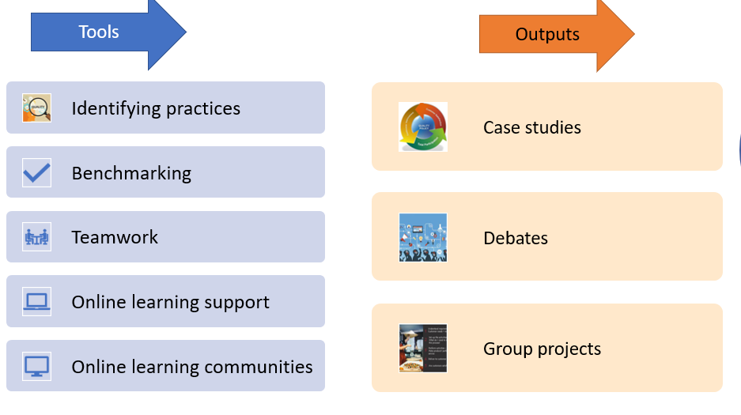

*Figure 1. Tools used and output obtained*

## Design

The main steps of the design process are the following:

* design of the Quality Management course
* first round of the course, data collection (observations, debate, and feedback)
* data analysis, optimization of the design of the first part of the Quality Management course
* design of the of the second part of the Quality Management course
* data analysis, optimization of the design of the second part of the Quality Management course, data analysis, case description, project report.

Considering the condition during the covid pandemic the focus was orientated on the application of the quality management and on the ISO 9000 and ISO 9001 standards understanding. The main purpose has focused on allowing the students the freedom to express their experiences and their ideas about the subjects discussed during the course and applications classes.

* *Design of the Quality Management course*

The first step was to rethink the structure of the homework they had at the course class and the project for the application class.

For the course homework the design steps were the following:

* The students were divided into teams of two.
* A list of subjects was created by the professor and the scheduled time for the presentation.
* Each team had to choose a subject.
* For each subject was mandatory to have at least two teams.
* Each team had to prepare a power point presentation to present freely the subject chosen in the day presented in the schedule.
* They received real-time feedback from their colleagues and from the teacher.
* Based on the feedback they had to develop a written report that was delivered at the end of the semester.

An example of the content of the presentation and final report can be seen in figure 2.



*Figure 2. Model of content for course homework*

A selection of course homework created by the students are presented in Appendix 1_Quality management Course homework.

The elements of the design used at the course class to develop the homework were:

* To describe the theoretical part of the subject they had to identify practices regarding quality concepts and principles and quality management system implementation.
* They need it to learn how to use teamwork effectively and efficiently.
* Inquiry-based Digital Education
* Online learning support – Moodle platform and MS Teams platform
* Online learning communities - <https://advisera.com/>

For the project the design steps were the following:

* The students were divided into teams of minimum 2 – maximum 4.
* They had to choose a subject (a product or a service).
* Each team had to prepare a detailed project for the chosen subject following the given content and having highlighted the key points of the project.
* They received feedback step by step from the teacher.
* Based on the feedback they had to improve the project and to deliver it in full at the end of the semester.

An example of content created for the project developed during the application classes is presented in figures 3a and 3 b.

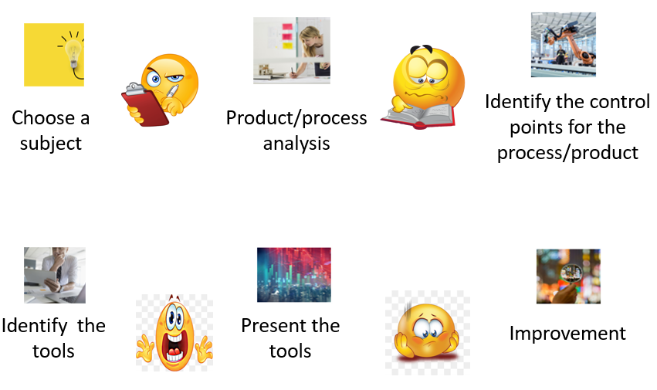

*Figure 3a. Model 1 of content for the project*

A selection of projects created using Model 1 of content created by the students are presented in Appendix 2_Selection of projects _model 1 content.

*Figure 3b. Model 2 of content for the project*

A selection of projects created using Model 2 of content created by the students are presented in Appendix 3_Selection of projects _model 2 content.

Example of project can be seen in figure 4.

*Figure 4. Model of project obtained*

The elements of the design used at the application classes to develop the project were:

* Identifying practices –product conformity evaluation
* Benchmarking – to choose an industry and a product for the project they had to do research and afterward to decide what to present.
* They need it to learn how to use teamwork effectively and efficiently.
* Inquiry-based Digital Education
* Online learning support – Moodle platform and MS Teams platform
* Online learning communities - <https://advisera.com/>
* *First round of the course, data collection*

The course design was delivered in the first step to bachelor students from Applied Informatics in Industrial Engineering (Romanian students) in the fall of 2021. The project design was applied on different levels to bachelor students from Applied Informatics in Industrial Engineering (Romanian students) and to master students Industrial Engineering (Romanian and Erasmus students).

The second step was to apply the design course to bachelor students from Quality Engineering and Management (Romanian students) in the spring of 2022.

* *Data analysis, optimization of the design of the first part of the Quality Management course*

Based on the feedback received from the students and the observations made by the professors during the classes the following conclusions had been drown:

* The students need more detailed information and guidelines to finish the task.
* They have problems identifying real life experience so the approach “learning by example” cand be a more effective way in helping them.
* The time given to complete the tasks was enough, taking into account the fact that they work in teams, the students said that it will be hard for them to do everything alone.
* The feedback received from their colleagues and from the teacher was a real help. In this way it was easier for them to make the necessary improvements to the course homework or to the project.
* For some of them the understanding of the standards was difficult.

Based on the feedback received some small modifications were made to the design for the course and for the applications.

* *Design of the of the second part of the Quality Management course*

The redesign steps for the course homework were the following:

* The students were divided into teams of two.
* A list of subjects was created by the professor and the scheduled time for the presentation.
* Each team had to choose a subject from the list.
* For each subject it was mandatory to have at least two teams.
* The teacher presented in advance basic information about the subject and examples of best practices.
* Each team had to prepare a powerpoint presentation to present freely the subject chosen on the day presented in the schedule.
* At the day of the presentation active listening and two-way communication was mandatory in the classroom
* They received real-time feedback from their colleagues and from the teacher.
* Based on the feedback they had to develop a written report that was delivered at the end of the semester.

The redesign steps for the project were the following:

* The students were divided into teams of a minimum of 2 – maximum 4.
* They had to choose a subject (a product or a service).
* They had to identify at least three companies in the same field of activity which are manufacturing products/ provide services in the same category as the subject chosen and identify good practices related to quality.
* Best practices from different companies were presented by the teachers in order for them to understand the requirements.
* Introducing debates on different topics related to the project.
* Each team had to prepare a detailed project for the chosen subject following the given content and having highlighted the key points of the project.
* They received feedback step by step from the teacher.
* Based on the feedback they had to improve the project and deliver it in full at the end of the semester.
* *Data analysis, optimization of the design of the second part of the Quality*

The redesigned course was delivered in the fall of 2022 at the same students and this time the feedback for them was positive. They didn’t have problems in delivering the tasks and it was easier for them to understand the standards and to identify practices.

## Experience/Results/Lessons learned.

The design was more effective for students than the classical way applied in the past. It can be used in online learning and face to face learning without any problems, so the main goal established was ensured.

The students developed valuable skills that will help them in the future, such as:

* Conducting research.
* Identifying quality practices.
* Understanding the principle of benchmarking.
* Working in a team.
* How to divide the tasks between the team members.
* How to effectively use digital platforms.
* How to identify product nonconformity and how to propose corrective actions.
* How to use the standards efficiently and effectively.

A lesson learned is that we need to adopt our classes taking into account the mindset of the new generations, what keeps them focused, how we can draw their attention and also the continuous changes that appear in the industry and services in businesses.

## Feedback from students/teachers

Based on the feedback received from the students and the observations made by the professors during the classes the following conclusions can been drawn:

* Overall, it was easier for them to approach the course homework and the project in teams.
* During the classes they learned how to listen to each other and how to use the knowledge and experience each team member must solve the tasks.
* Active listening and two-way communication were something new to them, but they learned how to freely express their opinion clearly and concisely on the subject presented.
* It was easier for them to cover the tasks by dividing the work equally between the team members.
* They liked this way of working even if it was something new.
* They found it challenging but help them a lot in identifying quality practices in real life experience and thus, better understanding the utility of the quality management principles.

Some of the lessons learned based on their feedback are presented in Figure 4.



*Figure 5. Lesson learned.*

## Redesign (optional)

After the first redesign we did not identify the need to modify it again, but that could happen in the future.

Day by day the products are evolving, the technology is changing and with them the quality criteria are changing so the course will always face new challenges.

The principles themselves may be applied for the course re-design and better fashioning in line with the economic, socio-cultural and political trends, perspectives and limitations.

## Challenges

The challenges that were overcame during the development and implementation of the Quality Management course were:

* To design learning activities and to select learning tools that will raise interest to the students.
* To study the student’s involvement into the course delivery and to always have an effective communication that is crucial for project-based learning activities, but it can be challenging to ensure that everyone is on the same page, especially when working remotely, because miscommunication can result in delays, mistakes, and even project failure.
* To mediate the project teams because the group projects were challenging due to the fact that students had different working styles, conflicting schedules, and different levels of commitment to the project. This raised disagreements inside the teams and sometimes delays. The master students preferred to work alone in order to avoid delays or project failures, but we succeeded to raise awareness of the teamwork importance to the bachelor students.

## Conclusions

Based on the methodology presented, the following conclusions can be drawn:

* Quality management it is related to every process and product/service inside a company, and it is always changing, evolving, and adding new elements.
* To choose the proper words to establish quality objectives it is sometimes hard because companies have to say in 4-5 ideas what quality means to them and the others to understand the meaning behind that objective.
* Relating to the Quality Management course it is hard to create a draft that will contain all the information from the standard and this is the reason why the focus should be on the application of it, on the documents and analysis that actually prove the quality obtained.
* This methodology proposed a new project-based design of the practical teaching activities in such a way to develop critical thinking, arguing, and debating, practices comparison and quality culture fertilizing.
* The project and the course homework were designed in such a way the students could express freely their ideas, opinions, and thoughts.
* The student’s feedback was positive, and they enjoyed putting on paper their own ideas of improving products, services, and processes. Also, they were able to find their own way of analysing data and presenting the information.

Overall, it was a process in which students and teachers learned a lot of things from each other’s and identified new ideas of how to increase the student’s interest in learning.